Classroom Workshop Plan
June 2015

For schools worldwide

Length of workshop: 70 - 100 minutes

List of materials:
A copy of worksheet 1 and worksheet 2 for every pupil and one copy per class of worksheet 2 (body) as a slide for overhead presentation (+ transparency pen).
Drinking straws for every pupil.
One feedback sheet for each class teacher.
Handout.pdf for every pupil.

Preparing for the classroom

Structure of the plan:
The plan is broadly divided into topics and suggests who could introduce each one. However, a workshop is inherently based on teamwork and everyone contributes. You will see the following symbols next to the different sections:
Partner , Partner , Teamwork

Tips for a successful workshop:
Keeping the class quiet

- From the outset, establish that pupils should raise their hands to speak.
- If noise levels increase, do not raise your voice. Instead, become quieter yourself.
- Address any disruptive pupils directly and ask them calmly if they have a question.
- These statements can also be helpful: “Please be fair and let your classmates have their say.”, We are doing this for you and doing it for free, so if you don’t want to join in, there‘s no point in carrying on and we can hand you back to your teachers instead.”
- Always speak slowly and loudly so that the pupils can follow everything.
- When presenting to the class, always keep moving. Don’t stand still in one spot.
- Make the workshop as interactive as possible and try to involve all the pupils.

Ensuring effective prevention

- Do not, under any circumstances, scare the pupils. Always remain objective. In the long term, fear is ineffective and pupils can easily come to associate feelings of disgust (e.g. at shocking images) with the people presenting the workshop.
- If you use the whiteboard, write in big letters.
- The fact that smoking makes people ill is already stated on cigarette packets and does not need to be reiterated. Therefore, we have deliberately kept that part short, so that pupils can spend longer learning about how exactly smoking causes different types of illness.

Conveying the key content

- By the end of the workshop, every pupil should understand why non-smokers have better skin, less spots and more money and why they are generally better-looking, fitter and freer to make decisions in their lives. If you are short on time, make sure you have covered these age-appropriate topics. They are marked in blue in the document.

Workshop Plan

Introduction:
Introduce yourselves and maybe write your names on the board. “Before we get going, we’d like to ask you a few survey questions:

- Hands up if you have friends who smoke.
- Does anyone have siblings or parents who smoke?
- Who has had a drag of a cigarette before?
- Has anyone ever been offered cigarettes? -> You could explore answers to this question further: How did you react? Why?

All of you have been confronted with this issue before – that’s why we think it’s important for you to be well informed about it. That’s exactly why we’re here today. “
About 5 minutes should have passed since the start of the workshop.

Interactive Topics
Less is more: mainly use questions to check that the pupils have really understood all the content included here. Always let the pupils answer first before helping them.

“What are the two main reasons why young people take up smoking?”
Peer pressure: most young people are persuaded to start smoking by their friends and are afraid of being excluded from the group. Advertising: the second most common reason for taking up smoking is advertising, which we really are exposed to almost everywhere. We will cover this topic in more depth later.
“Which target group is most easily influenced by peer pressure and advertising?”
Children and adolescents. The great majority of smokers start smoking in their early teenage years. (Why is this? They are not as well-informed and more impressionable.)

1) Skin damage
“To start with we’d like to talk about a very practical issue: tobacco smoke is bad for the skin. Smokers get more smoke in their faces than anyone else. Can anyone explain why this means that smokers generally get more spots?”
Usually no one can explain this. The best way to illustrate it is to draw a sketch on the board and explain how spots are formed: “At the base of the tiny hair follicles on your skin, you have small glands which produce an oily substance called sebum. It usually ensures that your skin doesn’t dry out. But if too much sebum is produced, the follicle can get clogged up and the blockage can swell up, forming a spot which can become infected. This can be caused by hormones during puberty, for example, but also by pollutants in the environment. So smoking can make acne worse or even cause it, because the chemicals in smoke irritate the skin.”
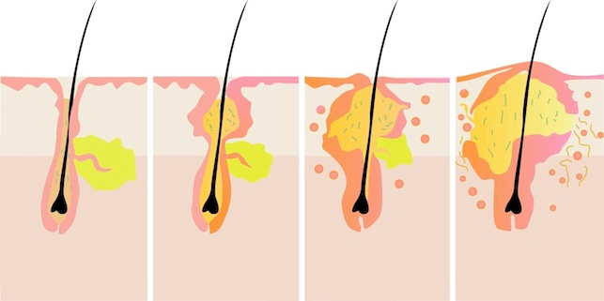
About 12 minutes should have passed since the start of the workshop.

Why do you think smokers tend to be paler than non-smokers?
“Smoking damages blood vessels in the body, including those in the face. A face with good blood circulation looks alive and healthy, but one with bad circulation looks pale.”– Allow other answers too, e.g. smokers have colds more often, etc.

Last but not least: Why do smokers get wrinkles earlier than non-smokers?
The pollutants in smoke, which spread out across all the skin on the face, irritate and cause stress to the skin. This causes the elastic fibres which keep your skin nice and taut and flexible to rip sooner. You know when you see old people with their cheeks hanging down and wrinkles everywhere? Smokers look like that much earlier on.

To check that everyone was listening carefully, hand out Worksheet 1 and let the pupils work on it independently for 10 minutes the short-term and long-term benefits. Take this time to relax, or walk around the room answering questions. At the end of the workshop, pupils will get a handout with the answers (tell them this at the end of the 10 minutes).

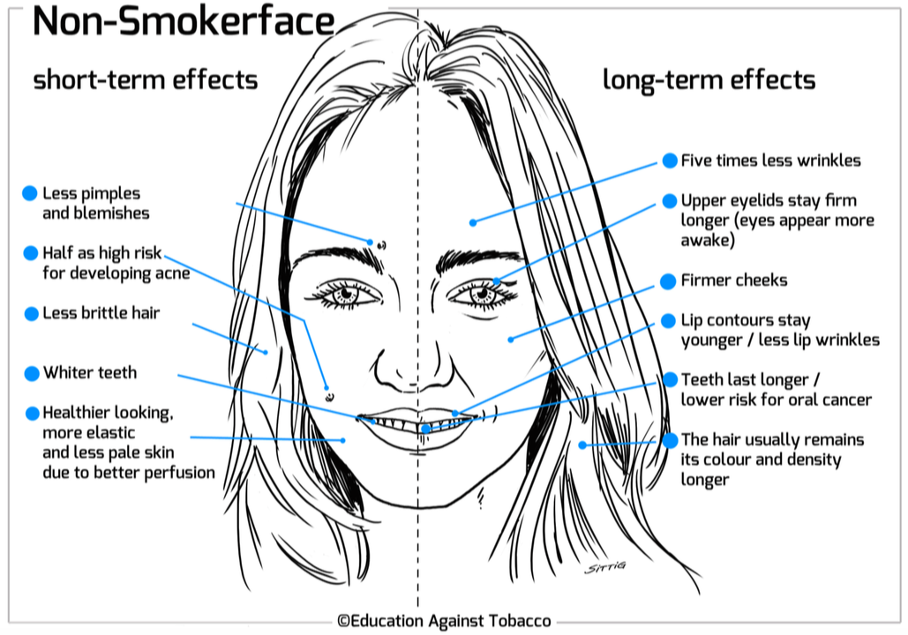
About 25 minutes should have passed since the start of the workshop.

2) The rest of the body

What about the rest of the body?

Hand out the unlabelled body diagrams to the pupils and ask them to start filling them out independently. You will help them afterwards. In the meantime, take the two healthy lung models over to individual groups of about five pupils and interrupt their brainstorming briefly (for about 2 minutes per group).

- “This is what a lung looks like; who can explain what we need them for?”
- “And how does a lung work?” (Help them if you need to: “every time you breathe in, air goes into the lung through your windpipe, and where does it go then?” (…) “That’s right, into the blood.” “Tubes, which we call blood vessels, transport air around your whole body in the bloodstream, so that every part of your body gets enough air.”
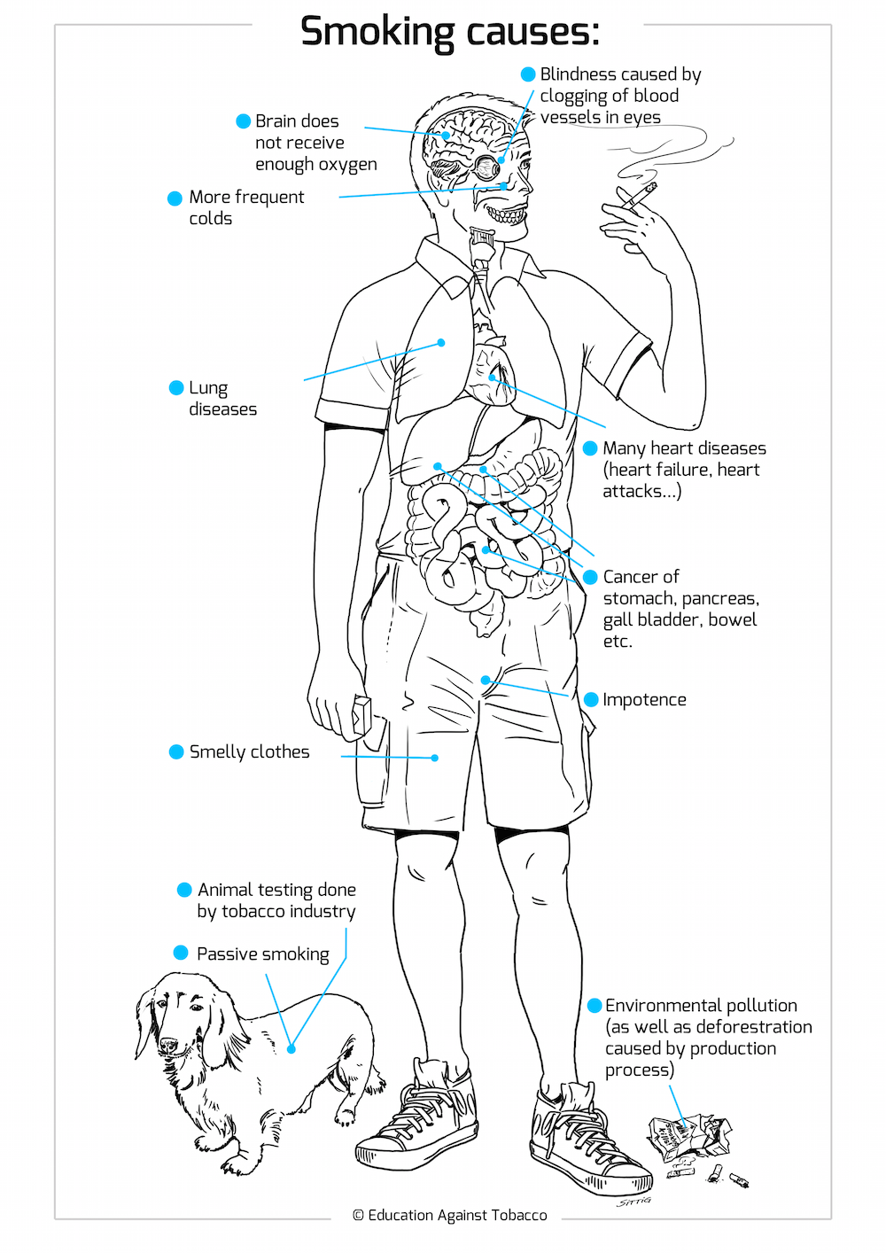
(In front of the whole class again, after you have demonstrated the models to everyone): “Why do you think non-smokers don’t just have healthier lungs than smokers, but the rest of their body is also healthier?”
Explanation: Pollutants get into the blood stream and therefore damage your blood vessels too. They make them narrower. They also damage all the organs because they are transported to them in the bloodstream. Let’s discuss the damage this does to our bodies (point out each different part of the body diagram in turn: “What would happen if the blood vessels that go to your brain became narrower? What about the ones that go to your eyes?” Etc.) You can put the worksheet on a transparency projector (if available) and fill it out while asking pupils for the right answers.
Special feature: Can you imagine what happens when a woman’s breasts doesn’t get enough air because the blood vessels that transport blood to them are too narrow?
The cells die out and the breasts become smaller and more flaccid. That’s why young women who don’t smoke usually have larger, firmer breasts. Smokers’ breasts tend to droop more because they have less elastic connective tissue. This information is much more relevant to female pupils of 12-16 years of age than any of the other diseases on the body picture. Discuss it and make sure that it is understood. Keep a relaxed attitude when discussing it.

About 40 minutes should have passed since the start of the workshop.

3) Drop in physical performance
(It is vital that you demonstrate this task, take part in it yourself and enthuse/motivate the pupils!)
- One partner hands out the drinking straws while the other partner or the teacher gives the first instructions.
“Hands up if you play any sports in your free time. Who plays football? Basketball? Baseball? American football? Good. We are going to do an exercise to show you how it feels to breathe when you’ve been smoking for a long time.”
Ask the pupils to stand up and do a few quick exercises (2 minutes altogether) – join in with them:
    - Back kicks for 15 seconds (“kicking yourself on the bum”)
    - 15 “jumping jacks”: (All count down together)
    - Raise knees on alternate sides for 15 seconds
    - Five press-ups
    - Finally sprint on the spot together for 20 seconds.

- Count down together, etc. Motivate pupils as much as possible and get them excited.
- Immediately after doing the exercises, pupils put the straw in their mouths and hold their noses (this must be demonstrated at the front of the class). Tell the pupils to stop when it becomes too difficult.

“Was it difficult to breathe?”
- Yes! Can you see why not a single professional athlete smokes? How could you play a sport under those conditions?
- The lung becomes diseased and stops working properly because tobacco smoke contains over 4800 harmful substances.
- The harmful substances spread from the lung throughout the whole body, which is why many other organs are also affected – for example, many men get erectile dysfunction – you could draw the circulation system on the board!
- Inside the lung itself, the mucous membranes are affected (this is why smokers spit so much) and the immune system is weakened: non-smokers get about three times less colds than smokers.

Make sure you collect the drinking straws at the end of the exercise, else they will become a distraction.

About 50 minutes should have passed since the start of the workshop.

4) Growth during adolescence
Who here would like to grow up to be smaller than they should have been as an adult?
Smokers often grow more slowly: the poisonous substances in cigarette smoke affect the hormonal balance during puberty. This is why smokers are much likelier to be short than non-smokers. In other words smokers often grow less during puberty.

5) Freedom and independence
“What does freedom and independence mean to you?”
- Being able to do what you want.
- Making your own decisions.
- Not letting yourself be influenced.
- Thinking for yourself.

“Almost all smokers are addicted. They can no longer decide freely whether they want to smoke or not - they have to smoke: What does it mean to be addicted? What is addiction?”

- Always having to think about something.
- Not being able to decide for yourself, but needing to do certain things.
- Being dependent and not free any more.
- Your actions are dictated by the addiction.
- Never having much money, because all your money is spent on the addictive substance.
- Withdrawal symptoms and bad moods.
- Something has control over you.

“What is the addictive substance in tobacco?”
The addictive substance is nicotine.
- Tobacco producers manipulate the nicotine content so that smokers stay addicted and cannot regain their freedom.
- 70% of smokers want to stop, but only 3-5% manage to.

About 57 minutes should have passed since the start of the workshop.

6) Advertising

“Imagine that you sell cigarettes and that your product kills thousands of your customers every day. In addition, it makes many people unfit, impotent, short and ugly. How would you get more people to buy it?“
- Advertising

Would you tell your customers the truth?
- No, no one would buy your product and you would go bankrupt.
Who would your ideal customers be?
- Young people and children, because they are the worst informed and most likely to believe the billboards. Also, they can smoke and buy your product for longer before they die.

How do they try to encourage young people to smoke? Can you think of any examples of advertising?
- We see actors smoking in films. Most of them don’t actually smoke, the just pretend to in order to get extra money from the tobacco companies!
- Large-scale billboard advertising: in total, the tobacco industry spends one billion euros a year on tobacco marketing.
- Formula 1 sponsoring, etc.

What do all types of advertising have in common?
- They try to associate cigarettes with positive things: a romantic kiss or a guitar player by the campfire. Smoking is actually more likely to prevent these desirable things than encourage them. For the most part, the people in the adverts are non-smokers. In some tobacco companies, smoking is even prohibited!

About 62 minutes should have passed since the start of the workshop.

7) Cost
Ask a volunteer who is good at maths to come forward and write down the workings out on the whiteboard. You and the class will help him. (If time is running out, skip the part where you work out the cost of one packet a day for a year (1680 Euros per year) and what they could buy with that money instead.)

Question: How much does a packet of cigarettes cost?
- You will usually get many different answers to this question. Pick a suitable one.
About 5 Euros is the average price.
- Then start the maths. How much would it cost to smoke:
  - One pack a day for a week? 5 €/day x 7 days = 35 €
  - One pack a day for a month? 5 €/day x 30 days = 150 €
  - One pack a day for a year? 150 €/month x 12 months = 1800 €

Question: What could you buy with 1800 Euros?
- The pupils will certainly have lots of ideas. (You can help!)
  - iPhone, iPad, laptop, scooter, holiday in Hawaii, etc.

About 68 minutes should have passed since the start of the workshop.

8) Shisha & e-cigarettes
Question: What about smoking shisha with tobacco? What do you think the differences are?
- Let the pupils vote: Who thinks it is just as dangerous? Who thinks it is more dangerous? Who thinks it is less dangerous?
- Tell them the answer: smoking shisha is just as bad for your health as smoking cigarettes. The tobacco used usually contains nicotine too and is therefore addictive. The water that is used in a hookah does not clean the smoke, it only cools it down. This means that the harmful substances are inhaled even deeper.

Next question: what about e-shisha/e-cigarette vapour?
- The vapour from e-cigarettes also contains substances which irritate the skin and cause cancer, but – as far as we currently know – in lesser concentration than in normal tobacco smoke. The vapour usually contains nicotine too, even in some e-cigarettes that claim to be “nicotine-free.” The manufacturers often deceive their customers and try to get them addicted so that they have to buy e-cigarettes for the rest of their lives. Many large cigarette companies also sell e-cigarettes, which should make you suspicious.
About 75 minutes should have passed since the start of the workshop.
9) Conclusion
Now that you have heard a lot of information about tobacco products, why do you think there are still people who smoke?

- Because they are addicted.
- Because they have been manipulated by advertising.
- Because they didn’t have to courage to say no when someone they knew offered them a cigarette.
- Because they think it relaxes you and helps you to cope with stress – but this is not true.

What can you do to relieve stress?
Sport, walking/jogging, playing an instrument, reading, spending time with your friends/partner.

How can you deal with peer pressure?
- Remind yourself that real friends don’t want you to harm yourself and will therefore accept a clear “no.”
- Decide for yourself and explain your opinion clearly: “No, smoking has too many drawbacks for me, just leave it.”

“Get your smartphones out”
- Download the free Smokerface App on your phone and show your friend approximately how their face will change if they carry on smoking for long enough, or if they start.
- We can recommend our free Smokerstop App for people who want to try and quit smoking.
- Write the App names on the whiteboard so that the students can download them anonymously later on.

Thank you! We hope you enjoyed it and feel well-informed now!!

Want to quit? Download the app Smokerstop on your phone -> from end of April 2015

Thank you for your help!

Optional exercise for pupils who are unable to stand up: (Or additional exercise if there is time to spare)
  - Ask the pupils to breathe in deeply.
  - Then ONLY breathe out halfway.
  - Breathe in again as deeply as possible.
  - Then only breathe out a little bit or halfway.
  - If possible, repeat the whole process 1 or 2 times.
  - Eventually the pupils will have to breathe out entirely as they will have too much CO2 and not enough O2 in their bodies.
  - Explain: that’s what it feels like to have a smoker’s lungs (emphysema), which chronic smokers usually develop in time. Emphysema sufferers have difficulty breathing out and can’t manage to get all the air out again that they have breathed in.

Tobacco facts to read in preparation

Who invented the cigarette? Ancient societies like the Mayans and the Aztecs smoked cigarettes. They have existed for a long, long time.

What’s the deal with smoking stones/shisha with steam stones? This is not well researched. Instead of tobacco, steam stones which are usually strongly flavoured and steeped in molasses and glycerine are placed in the shisha. Coal is still used to heat them up. What we currently know is that this does contain carcinogens both through the steaming materials and the coal. It is difficult to assess the health risks. They often also contain nicotine and are therefore addictive. For more information, see: http://tobaccocontrol.bmj.com/content/22/2/136.short

But I know someone who has smoked for 50 years and is still healthy, how is that possible?
Sometimes individuals miraculously survive plane crashes, but no one would claim that plane crashes are not that dangerous, or that they are desirable. A smoker who grows old has been about as lucky as the survivor of a plane crash. Furthermore, almost no one grows old as a smoker while still remaining in fairly good health.

Why do smokers get a “smoker’s cough“? The chemicals in cigarettes damage and irritate the lungs. The lungs try to get rid of them, for example by producing thicker mucus. So the smoker has to cough up this thick mucus as well as the tar and the other chemicals in cigarettes.

Are cigars dangerous too? They contain addictive substances and dangerous chemicals, just like cigarettes.

What if I smoke without inhaling? That’s impossible. You always inhale the smoke, even if you don’t inhale it straight away and you try and hold it in your mouth.

Are menthol cigarettes healthier? No.

What about Marihuana? Explain that as well as damaging your health, marihuana also lowers your IQ (“makes you more stupid”). The younger you are when you consume it, the more it affects you in this way.

What makes your teeth yellow? Tar and other substances in cigarettes.

How much money do tobacco companies spend on advertising? In Germany, a billion Euros a year are spent on tobacco marketing.

Why do tobacco companies put all these poisonous substances in cigarettes?
1) The cigarette must be able to burn and these chemicals are flammable; and 2) These chemicals are cheap, so although other (perhaps healthier) chemicals would burn too, using these particular ones ensures the biggest possible profit for the tobacco companies. The additives (such as vanilla, cocoa and other flavours) make smoking appealing to children and make it easier for people to take it up.

If smoking is so dangerous, why can’t the government simply make it illegal? Our government allows every adult the freedom to make their own decisions, even if some of these decisions are not particularly clever or healthy.

Please let us know if you think of anything that we should add to this list, or if you are asked a question that you don’t know the answer to, so that we can add the information onto this document.
Main source: dkfz.de/de/tabakkontrolle/

