New Classroom Workshop:

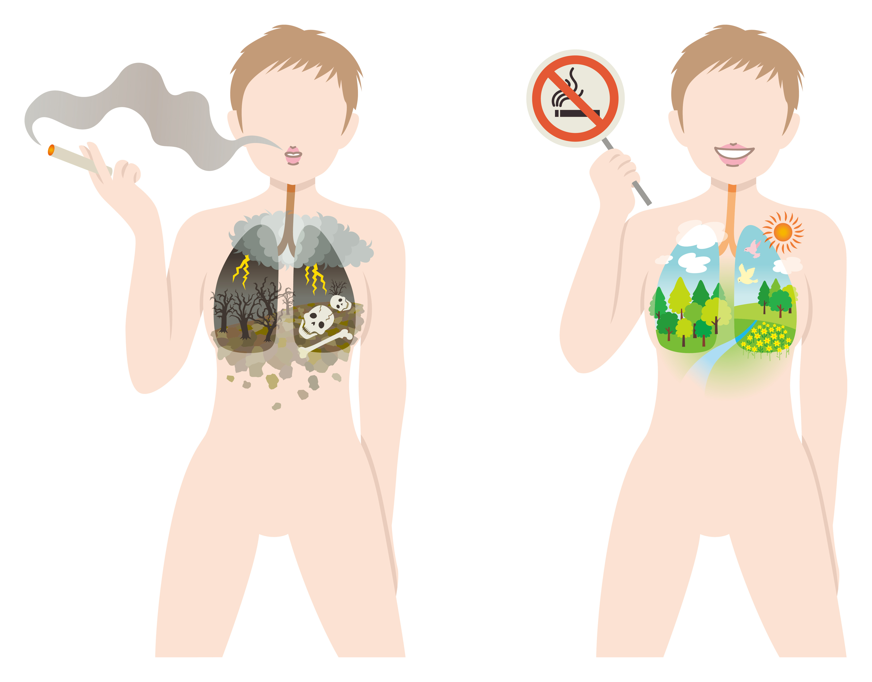
Plan of work stations 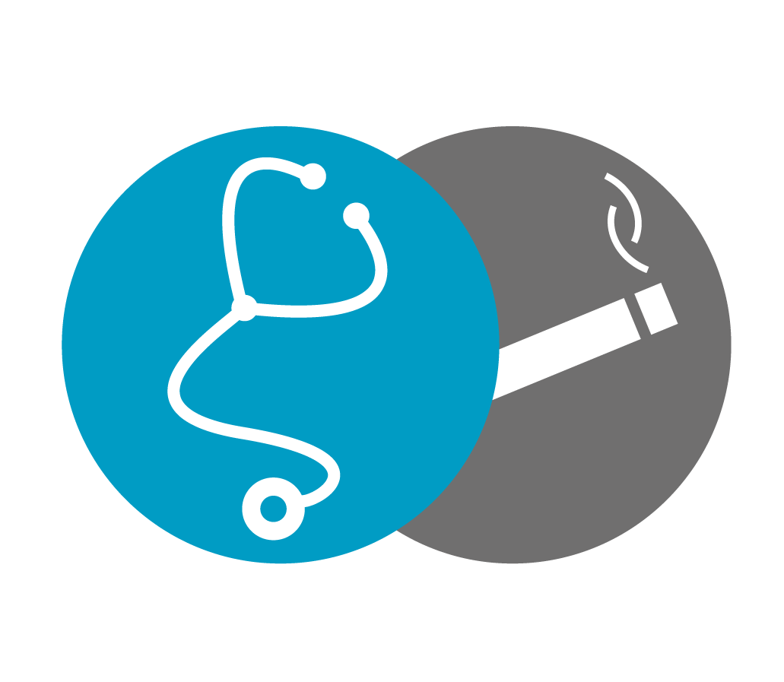

Outline:
1) General structure
2) Description of learning stations
3) Printable supplementary material (pdf handouts for stations)

General Notes
Necessary materials:

- Images of identical twins / standard growth curves
- Models of healthy bodies
- Drinking straws
- 2 x A1 posters per classroom with pins/duct tape to hang them up.
- Letters to pupils, parents and teachers (to be sent to your person of contact; if possible print them out and distribute them at school, otherwise print them externally)
- Raffa’s script (attachment)
- Tape with a writable surface

Successful workshop tips:

Don’t frighten students and remain objective. On a long-term basis, fear is ineffective. Students tend to associate disgust (deriving, for example, from shocking pictures) with the lecturer; it could affect your status as a role model. At this age, the propensity to take risks is very pronounced, especially in Hauptschulen and Realschulen. According to meta-analysis, the risk factor of smoking appeals to many kids who are already attracted to danger.

If you write anything on the board, make sure to write it big.
As the harmful effects of smoking are displayed on cigarette packets, this aspect does not need to be focused on for long. That is why this part has been kept intentionally short and the focus instead is on why smoking leads to illnesses.

Make the students use writable tape to make nametags. In this way, you can address disruptive individuals by name. Mentors should also have a nametag of their own or something similar.

3
2
Workshop setup:
1
4
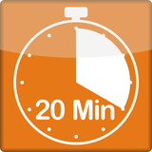
Divide the class into three groups. If there are only two students in the workshop, divide the class into two groups. The students are allowed to form a group with whomever they want. If problems arise during the group formation, ask the teacher to help you.
It is best to set the stations up quickly with the help of the kids. Push the desks against the walls etc. (setting up the room can be carried out during the class presentation with the teacher’s permission).
Four stations are set up in each corner of the room, making sure that they aren’t too close together. Station 3 has to be positioned near the board because students have to make a drawing. Station 1 must be placed by a window: ensure this happens during the setup. Every station lasts approximately 20 minutes.

1) General Structure
The opening presentation involves asking the students questions (ask the teacher to leave the classroom for 5 minutes and then to come back):

Who has already smoked? (Students raise their hands and, if applicable, you do too)
Who has parents or siblings who smoke? If the answer is yes, what do the parents tell their kids about it?
Are the kids allowed to smoke as well, or do the parents forbid it?
Who lives in a house or an apartment where someone smokes?

Rotation plan with 3 students per class

Station 1 | Station 2 | Station 3 | Station 4
Group 1 (A) | Group 2 (B) | Group 3 (C) | -
- | Group 1 (B) | Group 2 (C) | Group 3 (A)
Group 3 (A) | - | Group 1 (C) | Group 2 (B)
Group 2 (A) | Group 3 (B) | - | Group 1 (C)

When the work stations are finished, ask the students to formulate a final opinion in front of the whole class. This will generate a positive peer pressure and/or influence the students’ subjective norm [1].
Why do you think people smoke and what would be a good alternative? Stress, addiction, etc.
How could you help someone quit smoking? Write down the Smokerstop-App as a possible answer and stress that it is free with no ads.

Conclusion: The Drinking Straw Exercise

This exercise should illustrate the sensation of breathing with a smoker’s lung. The students have to do cardio exercises for two minutes (jumping jacks, push-ups, running in place and lifting the knees, etc.) and then breathe through previously distributed straws.

If you finish too early: ask questions about the topic and see if the kids understood everything or tell/have them tell stories from personal experience. If there is more time, you can talk about the university or studying medicine.
Don’t worry if you have not finished by then, it doesn’t matter! Put things away and summarize the essence of the work station in one or two sentences. If you have time left at a different station, catch up on unsaid things from another station.
Before the beginning of the workshop, choose someone who will be responsible for rotating the stations after 20 MINUTES at the latest. Everyone else should also monitor the time via a stopwatch.

2) Station Description

1. Different Ways of Consuming Tobacco and Extraction of Visible Components of Tobacco Smoke

Setup: This station must be set up by a window or outside! Tobacco products are displayed on the table.
Don’t bring the prepared bottle out from under the desk immediately; otherwise the kids will get too distracted.
Goal: What are you seeing? What are the differences?
Education about the different ways of consuming tobacco. Please stress that tobacco alone is already harmful, but many other pollutants are developed when it burns. Vaping products (e-cigarettes etc.) eliminate the burning and the result is a liquid that is considered less harmful.
(Spend 5 minutes at most on this!)

The second part is an interactive experiment that should show the harm of breathing in smoke and the way it colors and clogs the mouth, the airways and the lungs.
If you want to show a visual example, you can look for the video „Physiologie – Experiment zur Schädlichkeit von Zigarettenrauch“ on YouTube.

Experiment: “Plastic Lung”
It would be ideal if this experiment could be conducted outside. If there is a balcony / if the classroom is near to the outside recess area, the experiment can be conducted outside.

Explanation: As you surely know, there are many harmful substances in cigarettes and smoke can cause yellow teeth and lung diseases. We want to demonstrate this with an experiment.
Experiment setup: The bottle represents your lungs as it can exert suction because the water at the bottom pours out to create a vacuum. Therefore, the effect is similar to a person pulling on a cigarette and breathing in.
The fabric that will be exposed to the smoke is a handkerchief; it represents your lungs, teeth, oral mucosa, trachea, etc.
Place an unlit cigarette on top; it will be lit in due course.
The process:
- Fill the bottle with water and keep the lower opening shut. Place the cigarette in the bottle’s upper opening and make sure it is firmly in place.
- OPEN THE WINDOW: If possible, the whole experiment should take place on the windowsill; otherwise it will stink too much. Next light the cigarette and let the water run as the cigarette is consumed.
- Now remove the upper plug and hold a cloth over the upper opening. Insert the tube in the lower opening and blow the smoke out of the bottle. The air should blow past the cloth and leave smoke particles on it.
Discussion of the results: Show the kids the dirty cloth. Explain that all this filth would have travelled from their lungs throughout their entire bodies.

Do you know why you see young smokers constantly spitting on the ground? The body tries to defend itself from the filth, but it only works temporarily. After a relatively short time, the body gives up and the defense mechanisms fail.

Always use the same cloth for each group in order to achieve a more impressive effect. After three groups, the difference in color will be very pronounced. You should also show it around after the straw exercise to reinforce the conclusion. Allow the students to be as autonomous as possible (for example, let them put the cigarette in the opening, let them blow the smoke out).

2. Effects on the Face

Setup: Place images on transparency film and put Samsung tablets on the desk.
Goal: Show that consuming tobacco has visible consequences after a short period of time. At this station, we have images of identical twins. You can tell them apart because one of them smokes and the other does not. There are also tablets with the Smokerface app.
You should illustrate clearly that staying a non-smoker greatly benefits one’s looks. Even though the images mostly depict older people, you should stress that these effects are also visible in younger people after only a short time.

The process:
Distribute the images, everyone should pair up with a partner and talk about the differences they see.
- Increased wrinkle formation/skin aging: Nicotine causes the decomposition of collagen as well as hindering blood circulation, which causes the death of tissue. It also leads to the decomposition of the elastin protein (can you guess what elastin does?) that causes the skin to lose elasticity. Therefore, it leads to women’s breasts sagging and to cellulites worsening.
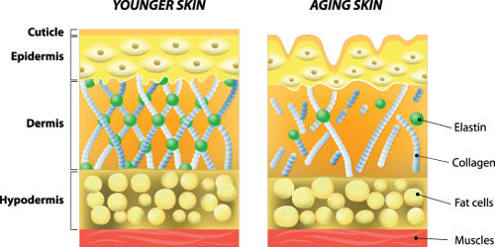
Explaining elastic fibers: Take a sheet of paper in your hands and pull it from both sides with your arms.

Now imagine my arms as the elastic fibers in your body. When you are very young, you still have many elastic fibers. When these fibers die, whether through age or smoking, the skin is no longer taut under stress. Therefore, it folds into wrinkles.

Show how your arms keep the skin (i.e. the sheet of paper) firm. When the fibers break, your arms no longer stretch it. That leaves the sheet of paper in a crumpled state, which represents wrinkling.

- Pigmentation disorder
- Teeth discoloration
- More pimples

Explain the illustration that shows how pimples develop: There are sebaceous glands in your skin, where you can usually also find hair. These sebaceous glands can become inflamed if filth or bacteria get inside them. Tobacco contains substances that increase the production of sebum, which facilitates the clogging of pores, turning them into a breeding ground for bacteria. Pus builds up and the pimple becomes bigger and bigger until it is squeezed. Nicotine also suppresses the immune system, thus favoring the development of pimples.

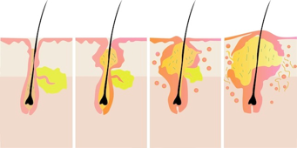
Smokerface tablets (ca. 5 minutes): See to it that interested kids take one more selfie and have the chance to play with their face. Make sure that as many classmates as possible in the group take notice.

3. Health benefits
that you experience in your own life

Setup: Place the body model on the desk; images can be on transparency film or laminated. (Growth curves showing growth disorders in male smokers in their youth can be included). You will then explain them from a gain-framed perspective (-> stress advantages for non-smokers).
Goal: Explain the long-term effects of tobacco, as well as basic notions about the human body and the position of organs within the body.

Show on the board how the diameter of blood vessels changes because of nicotine (the diameter shrinks. Nicotine has the effect of making the muscles in blood vessel contract. Along with other substances originating from tobacco smoke, it causes arteriosclerosis = deposits clogging the blood vessels. Non-smokers have better circulation.)
What effect does it have on the blood flow?
Less blood comes through with more difficulty:
higher pressure is needed to pump it through.
Experiment: “Arteriosclerosis”
Build a three-way valve with two different hoses. A volunteer student will use the syringe to inject water through the normal hose, then through the narrow one.
What is the difference? The narrow hose necessitates much more pressure. The blood flows faster and its pressure is higher.
In which case is the tube more likely to be damaged?

Show different organs, especially the ones that are most damaged by smoking (heart, lungs, brain).
What are their names and functions? How does tobacco consumption affect them? Highlight why organs work better in non-smokers:

Brain “Non-smokers can concentrate and relax more because they are not constantly on withdrawal and their brain receives more oxygen. “
Heart and lungs “Non-smokers are able to perform much better in sports.”
Heart “A non-smoker’s heart does not need to work as hard in order to pump the blood around the body. Blood pressure is much better in non-smokers. Higher blood pressure is bad in the long term because the heart is put under too much stress and the blood vessels are overstrained. Earlier during the experiment, XY had to exert himself/herself to pump the water through the narrow hose.”
Nose “Non-smokers are three times less likely to have a cold.”
Always “gain-framed” -> use positive wording and focus on the kids’ everyday life.

Think about it: None of the students have cancer; none of them truly identify with their Grandma/Grandpa or their illnesses enough to not smoke. It is therefore best not to go into the illnesses of the elderly, unless the kids themselves bring them up.

In case the subject is brought up, here is a possible short excursus about cancer etc.
“Cancer occurs when cells no longer work correctly because harmful substances cause changes in the genetic material. The cells then keep multiplying without knowing when to stop. Cigarette smoke contains over 100 harmful substances that can cause cancer.”

Systemic disorders:
Impotence in smokers “Circulation disorders hinder the flow of blood to the erectile tissue”.
Firmer breasts in non-smokers (more blood = more nutrients for firm tissues).
Less cellulite in women (smoking increases cellulite formation).
Better tissue healing in non-smokers “As nicotine causes blood vessels to shrink, not as many cells are available to reach the location of the wound and to heal it.”
Smoking hinders growth in young people who are not fully grown yet (i.e. the age of the students and boys are particularly affected). Unfortunately, even drinking a lot of milk won’t help with that :)[2]. Make a sketch on the standard growth curves to illustrate this effect (NS vs. S) (on average over vs. under 50 percentiles). The curve you draw should level off only from the 12th year on. Smoke suppresses lung growth both in men and women. This causes lower body performance in later life[2].
Overweight Smoke leads to not practicing sport, to an unhealthy lifestyle, to unhealthy eating habits. Dispel the myth according to which smoking makes you thinner. There is a short-term hunger suppression, but in the long term, as we saw before,
the average non-smoker is thinner!

When it comes to asthma, lungs react more strongly to substances in the air and a lot of mucous builds up. So what happens when thousands of harmful substances reach the lungs? Do you know smokers who need to spit on the ground all the time? Why do you think they do that?

4. Personal experiences: How can I keep away from smoking? What is addiction and how do I avoid it?

Everyone who has become addicted went through four stages:

- Being interested (interest).
- Starting to use (trying out).
- Becoming accustomed to it (habit).
- Being addicted (dependence).

This goes for every addiction, but it is particularly bad in the case of cigarettes/nicotine, because the addiction is very strong and more than half of all smokers become gravely ill and die from it.

Game: Addiction Memory

Structure: 16 cards with statements (covered), 4 cards with addiction stages (uncovered)

Process: The kids turn over the covered cards one after the other, read the statements aloud and guess which stage they belong to.
If they’re right, praise them and repeat shortly in your own words why the answer is right.
If it is wrong, ask students in the circle if someone else has another idea. Let the student who made the correction explain the right answer briefly.
(The mentor can find the solutions in Handout.pdf)
What experience have you had already with smoking? Can you identify with one of the statements?

How do you avoid addiction?

You should make your own decision. We can’t tell you what to do, but we can help you make a choice!
No matter at which stage you are, you must become aware of why you are there, if you want to be there and if it is good for you to be there.
It is always possible to quit tobacco, no matter at which stage you are (you can tell the same to your parents, most kids want their parents to quit smoking). To that end, we have made the Smokerstop app available on the market.

The most important thing about the station is to put yourself on the same level as the students, to be like an older sibling. Put yourself in their shoes and give them tips and advice on how to react.

Goal: You can say NO and NOT smoke, and still be cool! You also don’t have to be exposed to the harms of passive smoke.

What other possibilities do you have to relax? In the long term, smoking doesn’t help you relax nor does it make you happy; on the contrary, it brings constant stress and addiction because you always need more cigarettes. Non-smokers relax more!

At the end of the workshop, hang the two A1 posters you brought depicting a man and a woman. Hang them in a visible spot in the classroom.

1. Ajzen I: Theory of planned behavior. Handb Theor Soc Psychol Vol One 2011, 1:438.
2. O'Loughlin J, Karp I, Henderson M, Gray-Donald K: Does Cigarette Use Influence Adiposity or Height in Adolescence? Annals of Epidemiology, 18(5):395-402.

Attachment:
- Raffa’s script
- Pictures of identical twins

Raffa’s script: Tobacco products
Cigarettes

A cigarette is composed of 4 main elements:

a filter, a mouthpiece, paper and tobacco.

What effect is a filter supposed to have?
It is supposed to filter out harmful substances and it makes the taste of tobacco milder (that is why some smokers remove the filter). Studies show that the filter does little to keep out any harmful substance, because its pores are too large.

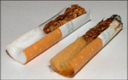
Filter before and after smoking
We can see clearly that the harmful substance in tobacco has left a brown residue on the filter. This also shows the cunning of the tobacco industry: the paper around the filter is colored brown so that the change in color will not be noticed!

Additional substances in tobacco:
- Caramelized sugar: It is supposed to make the smoke milder, increases the potential for addiction.
- Ammonia: It accelerates the flow of nicotine to the brain so that addiction sets in faster.
- Menthol, cloves: They lessen the feeling of irritation and pain in the respiratory tract so that smoke is inhaled deeper.
- Humectants.
- Shellac: It holds tobacco together. Shellac is a resinous substance obtained from the kerria lacca.
- Licorice, cocoa, tea, coffee: they are supposed to make smoking more pleasant.

Substances in smoke
Cigarette smoke contains over 12,000 substances that originate from tobacco being burnt. Among these, we find tar, carbon monoxide, hydrocyanic acids (over 200 of them are carcinogenic) and nicotine.

Cigars/Cigarillos

They are mostly the same thing. Cigarillos are just smaller.
They are comprised of 3 main components:
- Filler: The actual tobacco, it can contain up to 30 different kinds!
- Binder: It consists of a soft leaf in which the tobacco is wrapped!
- Wrapper: It is supposed to be a spotless leaf that contributes to the flavor and look of the cigar.

It basically contains the same substances as cigarettes, only in smaller quantities. Since its harmful substances are not filtered, it is ultimately just as dangerous. As the smoke does not reach the lungs, different illnesses manifest:
Cigarettes ---> lung cancer and other lung diseases (COPD/emphysema etc.)!
Cigars ---> mouth cavities, esophagus and larynx cancer!

Pipe

The differences between cigars/cigarillos and cigarettes are pertinent to this case as well. Since the pipe is more inconvenient, you could say that it is harder to use. After all, unlike cigarettes, it isn’t carried around every day.

Tobacco: It contains somewhat less additional substances regarding fuel and glue, but there is NO filter! No smoke reaches the lungs because there is only “puffing”. The differences in the illnesses caused are the same as those between cigars/cigarillos and cigarettes.

Shisha

A shisha (also called hookah) is built as follows and is comprised of 5 main components:
- Bowl (it holds the hot coal and tobacco).
- Stem (the tobacco smoke passes from here).
- Hose (it creates the vacuum necessary to inhale the smoke).
- Valve.
- Vase (it contains cold water to cool down the smoke).
When you smoke shisha, its tobacco contains the same substances as the one in cigarettes.
Additionally, this tobacco contains aromas that make shisha smoke seem “healthier”.
The strong pull at the hose and the colder temperature causes you to inhale the smoke deeper in your lungs!

E-cigarette

The e-cigarette consists of 6 main components:
- Mouthpiece (equivalent to the one in a regular cigarette).
- Liquid (it is vaporized, which substitutes the function of the addictive substances in cigarettes).
- Atomizer (needed to create vapor).
- Pressure sensor (it can sense a pressure being exerted during the inhalation and activates the atomizer).
- Cigarette body (it contains all electronics needed to keep the e-cigarette working, e.g. the battery).
- LED light (only needed to simulate the lit tip of a cigarette).
At the moment, e-cigarettes are assumed to be less harmful than ordinary cigarettes.

As of yet, no long-term study has been conducted about the harm of
E-cigarettes; however, early trials indicate less severe harmful effects.

Picture 1 – The smoker is on the right. Multiple wrinkles are visible on the forehead, around the eyes and the mouth. Overall, the non-smoker’s skin looks healthier.
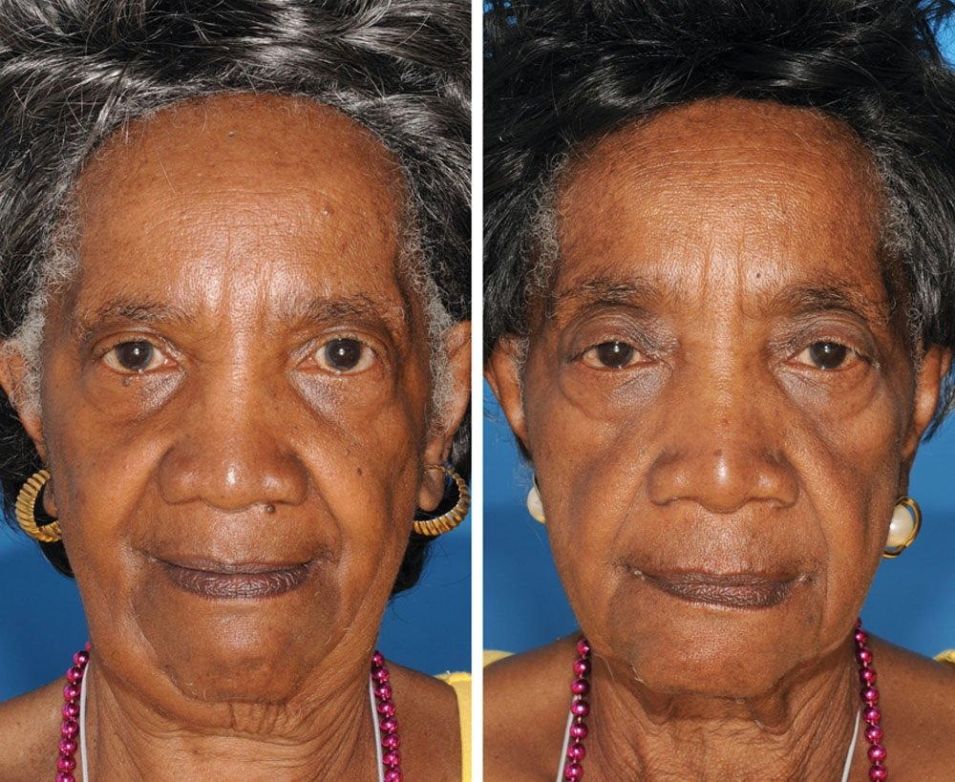

Picture 2 – The smoker is on the left.
There are more wrinkles; the circulation in the lips is worse; the condition of the skin is worse. The twin on the right looks about 15 years younger. 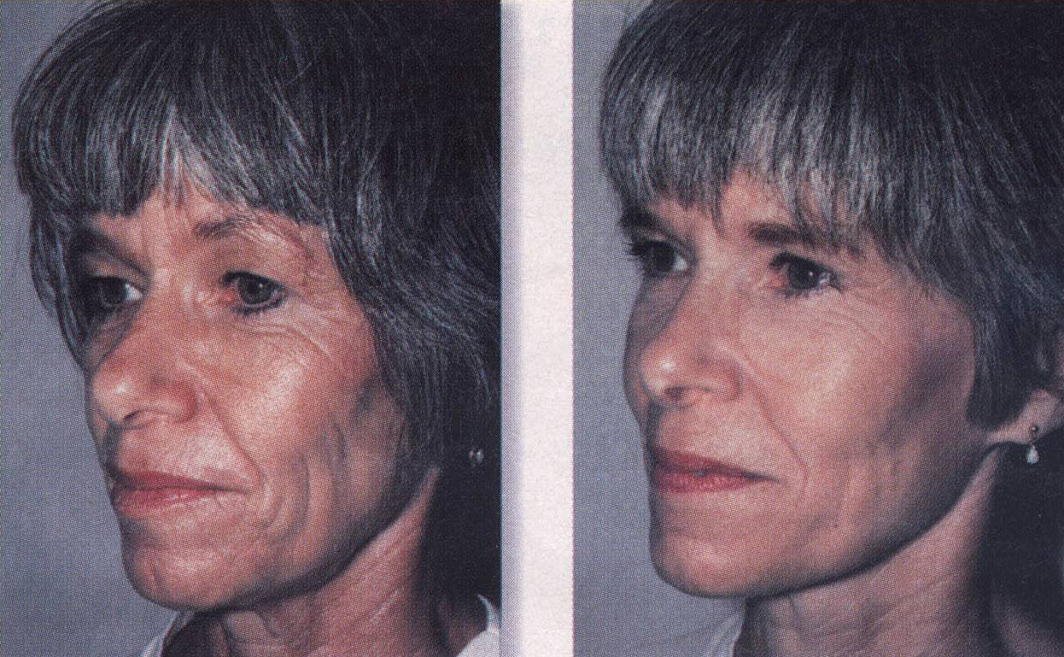

Picture 3 – The smoker is on the right:
Fatter and paler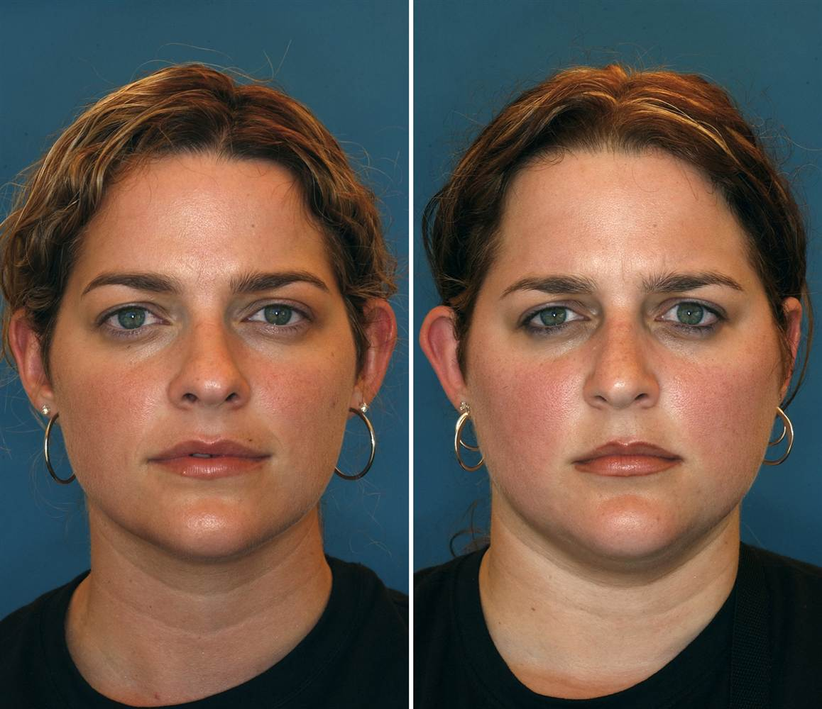

Picture 4 – The smoker is on the right:
The hair is in a worse condition and there are more wrinkles. The skin pigmentation derives from strong sun radiation.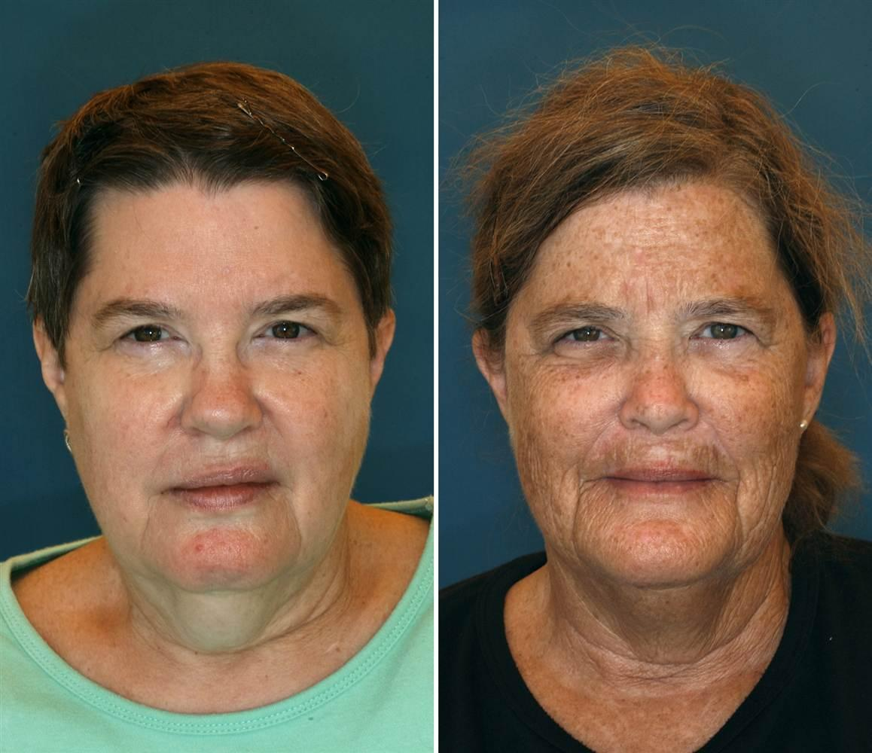

Translator’s note: “Hauptschule” and “Realschule” are two types of secondary school in Germany.
Physiology - experiment about the harmfulness of cigarette smoke

