EAT Workshop: Smoking Cessation 2018
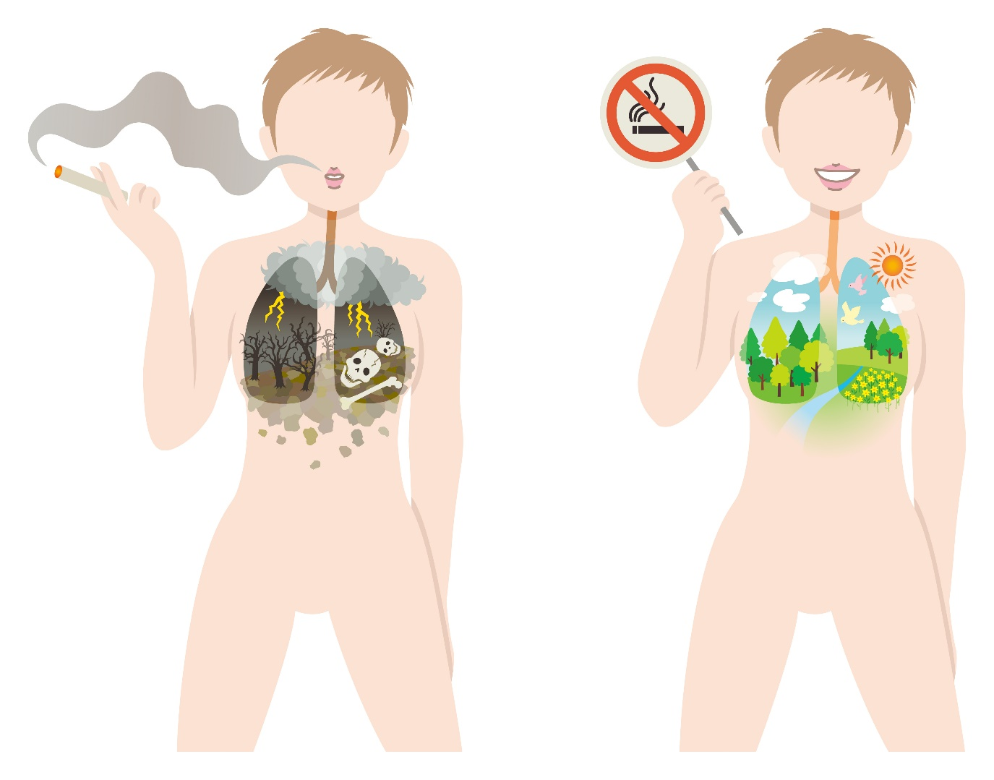

Target Group: Smokers, people interested in medicine (e.g. nursing students, medical students etc.)
Goal: To show a way into smoking cessation and give the students information about the smoking ban.
Duration: approx. 30 minutes
Authors/ Concept: Allesandra Holzem, Dr. Titus J. Brinker M.D.
International version: Benedikt Gaim
Part A: Introduction
1. Conditioning of smoking
Rituals and habits such as the breakfast cigarette in everyday working life or the digestive cigarette after a cosy dinner, which one actually does not want to do without, make it difficult to stop smoking. In this context, explain to the students the concept of the so-called conditioning of smoking. Smoking habits that you have trained over time or situations that you associate with smoking. In principle, however, it is nothing other than something accustomed and by overcoming the inner pig dog we can learn to stop. It takes control and strength, but it is feasible. Anyone who believes that cigarettes actually make it easier to cope with stress believes in a mistake. Smoking merely compensates for the stress of nicotine withdrawal itself. Non-smokers do not reach such a stress level at all. "̈For Smokers smoking is a break from withdrawal. They feel as liberated when smoking as non-smokers do all day. That's a paradox" says Dr. Eckart von Hirschhausen, German doctor and comedian.

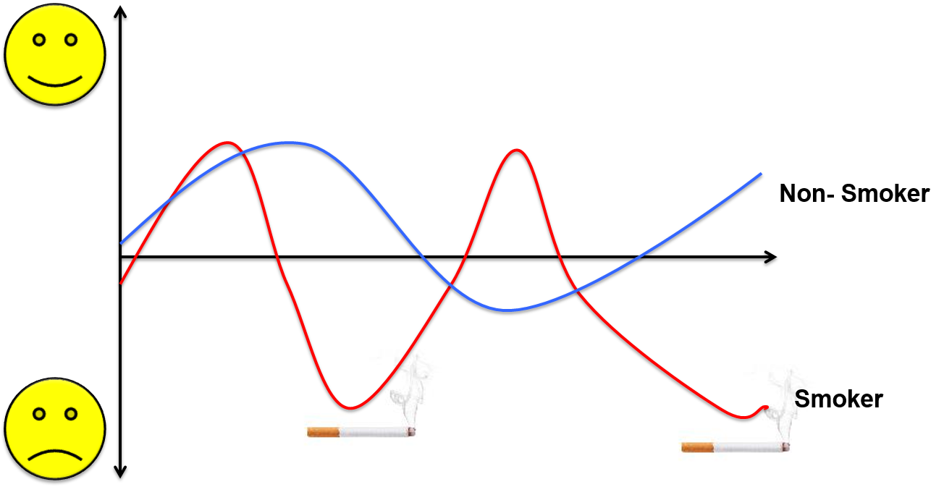

2. What are the symptoms of smoking cessation?
Nicotine is a nerve poison that can pass the blood-brain barrier. Nicotine binds to receptors in the brain. This process leads to the release of adrenaline, dopamine and serotonin. The release of these messenger substances triggers a feeling of reward, which leads to a brief feeling of relaxation. By mistake, the cigarette has become a stress killer. After a short time, however, your body gets accustomed to a nicotine attack, as the brain develops more receptors for dopamine, so that the craving for nicotine increases. If you now do without cigarettes, the level of dopamine decreases and the desire plagues you. Nicotine withdrawal therefore has some side effects that make it difficult to stop.
Make it clear to the students that physical withdrawal symptoms clearly subside already 7 to 10 days after the last cigarette. It should always be borne in mind that withdrawal symptoms are negligible compared to the negative health effects of smoking. Moreover, they are not the same for every smoker.
Part B: Interactive part
Material: poster/ whiteboard
Collect together on a poster withdrawal symptoms that may occur after a smoking ban:
Symptoms that can come your way:
- anxiety / nervousness
- depressive mood
- irritability
- weight gain
- Fatigue / sleep disorders

Now try to develop ideas to overcome the symptoms together.
What can I do about the withdrawal symptoms?
Distraction: Smokers' lips and fingers in particular are used to getting busy. Grab the apple instead of the cigarette. Waiting for the train or bus, call a friend instead of smoking.
Rituals: Create new habits for situations where you would have smoked earlier. So you need things to think about or do in these situations. For example, you could write on a piece of paper why you want to stop smoking forever and read it every time you get embarrassed to want to smoke a cigarette. Or you could take a little walk and get some fresh air. There are no limits for your creative mind.
Exercise: Sport demonstrably fights the desire for cigarettes and improves your physical fitness. Vitality and performance motivate to persevere and create a whole new self-confidence. The sporty distraction from cigarettes.
Healthy food: After the smoking ban, many people increasingly reach for food to compensate for the lack of tobacco consumption. To avoid a strong increase in body weight, you should pay attention to what you are ingesting. Raw food, fruit and smoothies are just a few examples of healthy alternatives.
Sufficient sleep: After enough sleep you feel fitter and more motivated. Ideal conditions to withstand the withdrawal symptoms. But not only the duration of sleep is decisive, but also the quality of sleep.
Relaxation exercises: Sleep is not the only way to relax. Relaxation exercises can provide relief in stressful situations. Well- known techniques include yoga, autogenic training or progressive muscle relaxation, in which muscles are specifically tensed and relaxed back below their initial level. For example, simple breathing exercises can be easily integrated in everyday work.
Enjoy leisure time: Consciously use the time saved by the smoke stop for things that give you pleasure. Go about your hobbies, travel around the world or spend time with friends. Here you are distracted from smoking, too.
Patience: Your body needs time to get used to the new living conditions without nicotine. Withdrawal symptoms are reduced to a minimum after a few weeks and do not last a lifetime. Even if it can be very difficult to stop smoking, you have to make it clear to yourself that the withdrawal symptoms will pay off. The smoking ban puts an end to the consequential damage associated with tobacco and starts a completely new, healthier phase of life.

Part C: Smokerstop App
Material: Tablets, App „Smokerstop“ (free Download for Apple and Android)
Afterwards, each student should take a tablet in their hand and get to grips with the Smokerstop app. Smokers enter some information about their smoking behaviour when starting the app, non-smokers should adopt the default settings and take a look at the functions of the app. Let the students spend five minutes exploring the app and its features. Then ask the nursing students for their opinion of the app.

It is important to take away the uncertainty of the nursing students with regard to the smoking ban. After our visit they should feel encouraged to try and concerns should be removed.

Feedback and more ideas:
Please write to gaim@educationtobacco.org or info@educationtobacco.org.

Sources (in German):
NichtraucherHelden.de, Tipps gegen Entzugserscheinungen beim Rauchen - wie schlimm sind sie wirklich?, https://www.nichtraucherhelden.de/magazine/tipps-gegenentzugserscheinungen-beim-rauchen-wie-schlimm-sind-sie-wirklich-41 (02.05.2018, 10:31)

